Programming Foundation With Pseudcode (15 Marks)
- Write a pseudoid to accept one of the below Rating from the user, then Identify the Feedback. Accept the Rating should not be less than or equal to one and should not be greater than 10. Accept the type of service they have taken and the vehicle details like Type and Cost of Vehicle to calculate total amount to be paid for the service. Make use of best practices and exception handling.

Rating | Feedback | Vehicle Type | Type of Service | Cost of service
1-5 | Poor | All | F | 200
5-7 | Average | Hatchback | BR | 15% cost of vehicle
8-9 | Good | Small Cars | BR | 10% cost of vehicle
10 | Excellent | Sedan | BR | 18% cost of vehicle
Table 1
*F = Free Service *BR = Body Repair

HTML and JavaScript (30 Marks)

- Design a web page to accept customer and vehicle details using HTML 5 and CSS and perform the following validations.

- All fields are mandatory (none can remain blank)
- Sur Name should be using list box
- State and City should be populated via List boxes
- Customer Name should accept only alphabets with length greater than 5.
- Email id should be valid Email Id
- Mobile number should be of 10 digits.
- Pin Id of 6 digits includes space Eg: xxx xxx
- Car model should be from an drop down list.
- Write a javascript function to
  - Validate whether Type of Service is selected or not.
  - “Your Feedback” should accept numeric input in the range of 1-10 alone and based on the input respective “Feed Back” as you refered in the above “Table 1” should be displayed in the same Text box.
- If all the data is valid display the following message in an alert box while clicking on “Submit” button .

“Thanks for your Valuable Feedback <<SurName>>.<<CustomerName>>.”

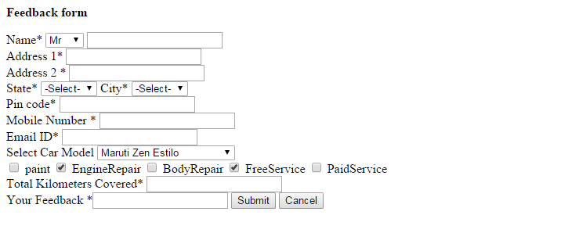

- Create tables with following specifications & Insert 5 rows.
Sections
Column Name | Column Type | Constraints
Section_id | NUMBER | PRIMARY KEY
Section_Name | VARCHAR2(15)

Insert below records in Section Table
Section_id | Section_Name
11 | Maths
21 | Science
31 | History
41 | Geography
51 | Theology

Participants
Column Name | Column Type | Constraints
Participant_Id | NUMBER | PRIMARY KEY
Participant_Name | VARCHAR2(15)
DOB | DATE
Fees_Applicable | NUMBER
Gender | CHAR(2)
Section_Id | NUMBER | Foreign Key

Insert below records in Participant Table
Participant_Id | Participant_Name | DOB | Fees_Applicable | Gender | Section_Id
001 | Rohan | 10-JAN-1996 | 48000 | M | 21
002 | Manjula | 10-NOV-1997 | 34000 | F | 11
003 | Vaishali | 19-DEC-1996 | 45000 | F | 41
004 | Vivek | 23-JUN-1994 | 48000 | M | 21
005 | Roseline | 05-FEB-1997 | 67000 | F | 31

- Solve below queries. (Any 3) (15 Marks)
- Display Participant_Id, Participant_Name, DOB and Section_Name for all Participant.
- Display Participant_Id, Participant_Name and Fees_Applicable of all Participants whose name starts with “V”.
- Display name of all Participants who belong to Section 11 or 21 or 51.
- Display Participant_Name and Fees_Applicable for those Participant, who were born after 1994.
- Display number of Participant as per the Gender.

Section 4 – XML ( 5 marks Each)
- Write XML document based on Participants table given in section 3.
- Write Schema for XML file created in the above question and validate the XML file

